
Information Engineering Technology
Project Name: Room Availability System
Subject: Software Engineering Semester: 4th
SUBMITTED TO:
Ma, am Javeria Saeed

SUBMITTED BY:

Sr. | Name | Roll No.
1 | Syed Abdul Hannan | SU91-BIETM-F24-021
2 | Badar Arshaad | SU91-BIETM-F24-024
3 | Muhammad Amir | SU91-BIETM-F24-034
4 | Sana Fatima | SU91-BIETM-F24-027
5 | Maira Sarwar | SU91-BIETM-F24-003

Introduction

Purpose:
The Smart AI Campus Room Availability System is a web-based and/or mobile-enabled platform designed to automate room booking, manage real-time availability, and eliminate scheduling conflicts within a campus environment. It provides intelligent scheduling assistance, ensures optimal utilization of campus spaces, and reduces manual administrative workload.
Scope of the project:

The system will be used in educational institutions such as colleges and universities.

It will manage room booking for classrooms, labs, seminar halls, and auditoriums.

Users will be able to check real-time room availability before booking.

The system will support multiple user roles like admin, faculty, and students.

It will help in reducing scheduling conflicts and double bookings.

The project may include AI features for smart room suggestions in future upgrades.

Overview:

This document provides system description, requirements, design models, database structure, and project timeline.

Problem Statement:

Manual room booking systems cause:

Double bookings

Scheduling conflicts

Delays in approval

Poor tracking of room usage

The AI Smart Campus Room Availability System solves these issues by providing automated, real-time management.

3 Project Objectives:

To automate the campus room booking and scheduling process

To provide real-time updates on room availability

To prevent double booking and scheduling conflicts

To improve efficient utilization of campus rooms and facilities

To reduce manual work and administrative burden

To offer AI-based suggestions for better room allocation

To ensure easy and user-friendly booking experience for users

To generate reports for monitoring room usage and performan

4 System Features:

User Management:

Role-based access (Admin, Faculty, Student, Staff)

Secure login and authentication

Profile management

Room Management:

Add, update and delete rooms

Define room capacity and type (lecture hall, lab, seminar room)

Equipment tracking (projector, smart board, etc.)

Booking System:

Real-time room availability calendar

One-click booking request

Approval workflow (optional for admin-controlled systems)

Recurring bookings support

AI-Based Scheduling Assistance:

Suggest optimal rooms based on capacity and availability

Recommend alternative time slots during conflicts

Predict peak usage times

Notifications Syst:

Email/SMS and app notifications for:

Booking confirmation

Booking rejection

Schedule changes

Upcoming bookings

USE CASE DIAGRAM:

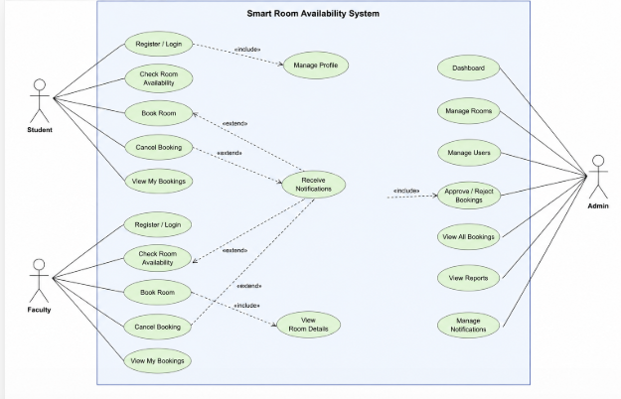

Project Requirements

Functional Requirements:
- User registration and login
- View room availability
- Book rooms
- Cancel bookings
- Admin can manage rooms
- Admin can approve/reject bookings
- Generate reports

Non-Functional Requirements
- response time under 3 seconds
- Password encryption and security
- 99% system availability
- User-friendly interface
- Scalable architecture

Technologies Used

HTML

CSS

JAVA
- Python (Backend)
- MySql(Database)

XAMPP / Local Server

Feasibility Study
A feasibility study is performed to check whether the project is practical, achievable, and beneficial for the university.

Technical Feasibility:

The project is technically feasible as it can be developed using common technologies like HTML, CSS, JavaScript, PHP, and MySQL. AI-based features can be implemented using Python.

Operational Feasibility:

The system is easy to use for students, faculty, and administrators. It improves the existing manual booking process by making it faster and more efficient.

Economic Feasibility
The system is cost-effective because it uses open-source tools and does not require expensive hardware or software. It reduces manual workload, saving time and administrative costs.

Schedule Feasibility:

The project can be completed within the given time frame as it has a clear structure and uses familiar development tools.

Requirement Prioritization:

High Priority:

Room Booking System

Real-Time Availability

Admin Management

Conflict Prevention

Medium Priority:

Notifications

Reports

Future Enhancement:

AI-based room suggestions

Validation

Requirements were reviewed to ensure they are:

Clear

Complete

Achievable

Aligned with project objectives

System Requirement

Laptop or Desktop

Python

MySQL

VS Code

Users of the System

Students

Faculty

Admin

Gantt Chart:

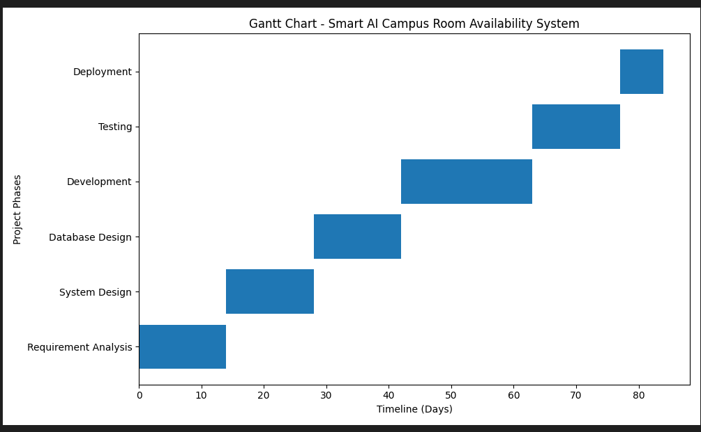

Conclusion
The AI Smart Campus Room Availability System is an efficient and secure solution for managing campus rooms. It automates booking processes, prevents conflicts, and improves resource utilization. The feasibility study confirms that the system is technically, operationally, economically, and schedule feasible. Therefore, it can be successfully implemented in a university environment.
.

